MINOR PROJECT REPORT



DEPARTMENT: COMPUTER SCIENCE & ENGINEERING

MENTOR: ER. GAURAV RAJ

SESSION YEAR: 2019 - 2020

TEAM MEMBERS: Mansi Agarwal (8817103019)

Ankur Agarwal (8817103010)

Gaurav Bansal (8817103015)

**CERTIFICATE**

This is to certify that the work carried out by Mansi Agarwal (8817103019), Ankur Agarwal (8817103015) and Gaurav Bansal (8817103015). Entitled on “**GIMPAY TACK**” is carried out by them under my supervision and guidance. The matter embodied in this report is original and has not been submitted for the award of any other degree.

**Mentor’s Signature**

**INDEX**

Certificate Page 2

Problem description Page 5

Scope/Objective Page 6

Applications/Features Page 8

Hardware/Software used Page 9

Tools and techniques used Page 10

Technical description Page 11

Diagrams Page 12

Overview of the project Page 15

Implementation details Page 17

Database Authentication Page 24

Backendless server Page 25

API key Page 27

Realtime database Page 28

Screenshots of code Page 30

Limitations and future enhancements Page 32

Conclusions Page 33

References Page 34

**PROBLEM DESCRIPTION**

**ABOUT THE PROJECT:**

As the title suggests, the application will be a android application for a company. The users will be the employee of the company and the admin. It will be a payroll and location tracking system for the fair distribution of the salary to the employee. **The main benefit of this application will be to help the admin to keep track the track of job holders. Furthermore, GPS location of the employee is tracked, so employee will not attempt to add proxy attendance.**

**INTRODUCTION:**

**User Role**

* When the user logins to the system, the image will be captured and will be shared via WhatsApp.
* After Login, the user will send the location on receiving the notifications in a time duration of one hour.

**Admin Role**

* Admin does his login.
* He views the location updates on backendless map.
* He will get the location updates via marks on google maps located on backendless geo location.
* After viewing the location status he updates the payment of particular employee.

**SCOPE/OBJECTIVE**

The main objective of this project is to develop an android application which will keep track of the location and payroll of the jobholders and it will keep a record of the payments which will be distributed to the job holders.

**SCOPE:**

* The project can be extended to a web application which may only include HR and admin logins.
* The HR may ensure that admin had honestly updated the payments of employees.
* May be applicable in delivery system where the employees do part-time job and payment will be on the basis of packages delivered.

**ADVANTAGES**

* To prevent proxy attendance which may be marked by employees.
* Applicable in the fields where distribution of salary is based on location.
* This System helps the admin to keep track of the employees who go for field work.
* No Proxy attendance because the captured image which will be shared via whatsapp depicting that the employee has reached the office.

**APPLICATIONS/FEATURES**

This project is proposed for the betterment of company. This project aims to help the admin for a fair distribution of the salary of the individual employees.

**FEATURES:**

* **Admin Login :-** Admin will access the system with admin email_ID and password.
* **View Location: -** Admin can view GPS location of the particular employee by entering employee Email_ID and date.
* **Update Salary:-** Admin can check salary of the employee by entering employee id and date.
* **View Point: -** Admin will view latitude and longitude of the GPS location of the employee.
* **Check Location:** ADMIN can check GPS location of the employee by entering employee EMAIL_ID and date.
* **User Login: -** User will access the system with his user identity EMAIL_ID and password with his android phone. User will capture his image and clicks on submit. User’s Image and GPS location will send to admin.
* **Send GPS Location: -** System will send location to the server after getting notified with in a time span of one hour.
* **User Logout: -** Once the user logout the system image of the user and current GPS location will be send to admin.

**HARDWARE/SOFTWARE USED**

**Hardware Used:**

* 8GB RAM
* Intel Core I5/Windows OS.

**Software Used:**

* Microsoft window 7/8/10(32 or 64 bit).
* Android Studio.
* Java version-java development kit (JDK).

**TOOLS AND TECHNIQUES USED**

* **Firebase Realtime Database:** This functionality is used by admin to fairly update the payment of a Prticular employee on a pre decided criteria set by a company domain.
* **Firebase Authentication:** This functionality is used to verify that the correct user and login are login into the system.
* **Backendless:** It is a platform which provides the global map with metadata to save the location updates.
* **Adobe XD:** The designing part of the user interface was implemented using this software. The logo and the buttons were customized using this tool.

**TECHNICAL DESCRIPTION**



The design of this project is divided into 3 phases as described below:

* UI design
* Database Design
* System Design
* **UI design:** In this phase the UI or the user interface of the project is developed. That is, the designing of the XML files which the user will use to interact.
* **Database design:** The database is considered to be the main pillars of every project. In our application, database is used to store user details such as email, password etc. The complete proposed design of the database is shown in the firebase authentication in the dashboard. This dashboard shows all the registered mail with their respective reference id’s.
* **System design:** In this phase a complete flow diagram of the working system is designed. This flow diagram will show the details of all the events like actions to be performed for an event.

**DIAGRAMS**

**DATA FLOW DIAGRAM (DFD):**

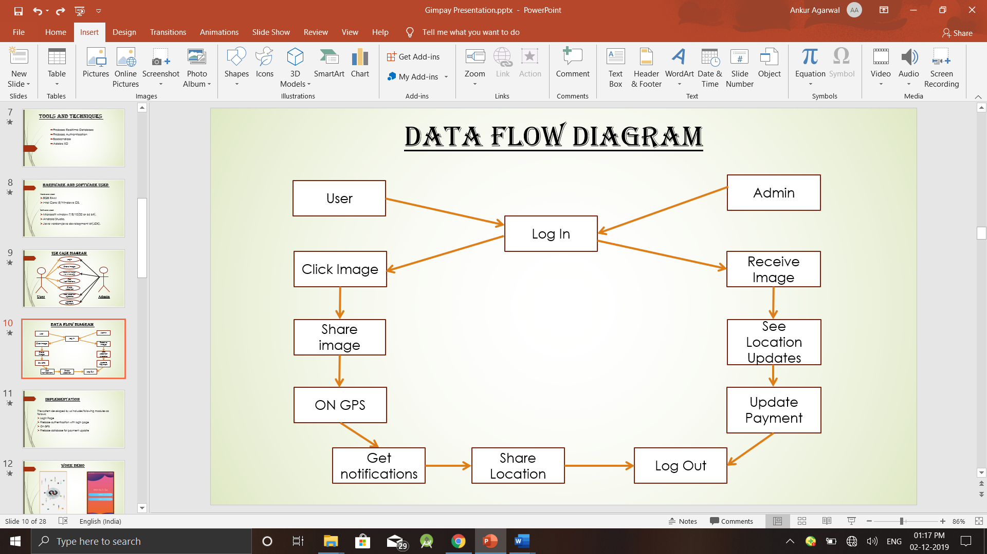

**EXPLANATION OF ABOVE DFD DIAGRAM:**

**User Role**

* In the diagram, the user logins to the system by entering the valid email and password.
* He clicks his image and share via whatsapp to mark his attendance.
* After that he gives the permission to allow the location services access, he shares his location.
* He gets notified after one hour to send the updated location.
* After that he logout of the system.

**Admin Role**

* In the diagram, the admin login to the system by entering the valid email and password.
* He receives the shared image of employees on whatsapp.
* He sees the location updates on backendless server via marks on google maps.
* He updates the payment of the employees after observing the whole day activities of the employee.
* After that he logout to the system.

**USE CASE DIAGRAM:**

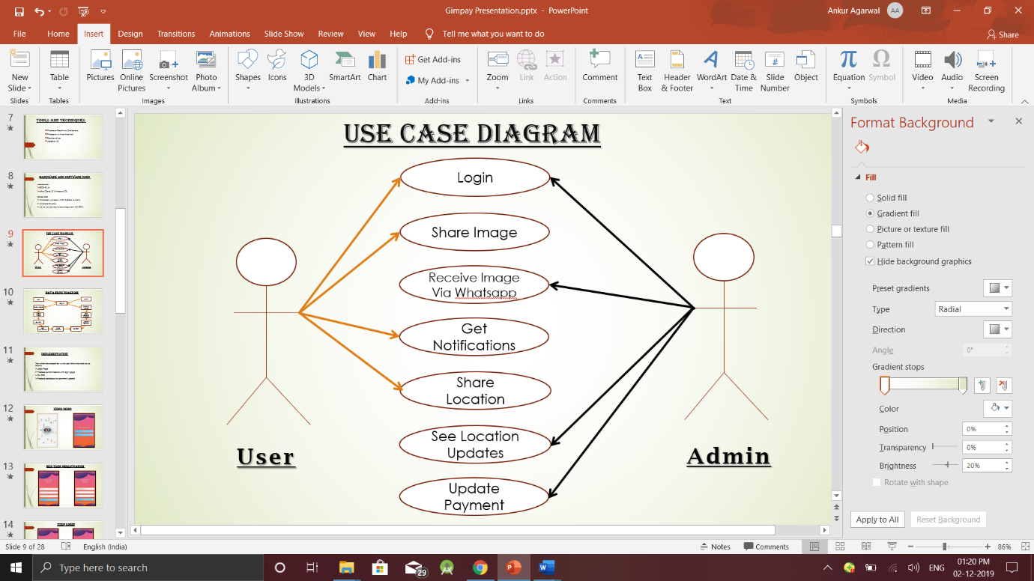

**EXPLANATION OF ABOVE USE CASE DIAGRAM:**

* The diagram consists of three actors those are USER, ADMIN and seven use cases those are: Login, Share Image, Receive Image Via Whatsapp, Get Notifications, Share Location, See Location Updates, Update Payment.

**User Role**

* Login in the system
* Share Image Via whatsapp to mark the attendance.
* Gets notified after one hour to send the updated location.
* Shared the locations.

**Admin Role**

* In the diagram, the admin login to the system by entering the valid email and password.
* He receives the shared image of employees on whatsapp.
* He sees the location updates on backendless server via marks on google maps.
* He updates the payment of the employee after observing the whole day activities of the employees.
* After that he logout to the system.

**OVERVIEW OF THE PROJECT**

This system is an android application where the user and admin will be using the android application. This application is meant for job holders. The user and admin will have this application in his android phone, when the user will login to the system his image will be captured and his GPS location will be started to track send to the admin where admin will view image and GPS location in application. After Login, GPS location of the employee will be sent to the sever on getting notified after a time span of one hour. In order to keep track of the attendance as well as payroll of the field work people, this system plays a major role. The role of the admin is to add new employee by entering his personal details and admin will provide the employee with identity e-mail and password to the user so that he can access the application in his android phone. Admin can view the GPS location of the employee by entering Employee Identity e-mail . Admin can update the salary. Since GPS location of the employee is tracked, so employee will not attempt to add proxy attendance.

**Such modules are :**

* **Admin Login :-** Admin will access the system with admin email- ID and password
* **Add Employee:**- Admin will add new employee by entering employee personal details.
* **View Location: -** Admin can view GPS location of the particular employee by entering employee Email_ID and date.
* **Update Salary:-** Admin can check salary of the employee by entering employee id and date.
* **View Point: -** Admin will view latitude and longitude of the GPS location of the employee.
* **Check Location:** ADMIN can check GPS location of the employee by entering employee EMAIL_ID and date.
* **User Login: -** User will access the system with his user identity EMAIL_ID and password with his android phone. User will capture his image and clicks on submit. User’s Image and GPS location will send to admin.
* **Send GPS Location: -** System will send GPS location of the employee and will be sent to admin after every one hour.

**IMPLEMENENTATION DETAILS**

**LOGIN PAGE:**

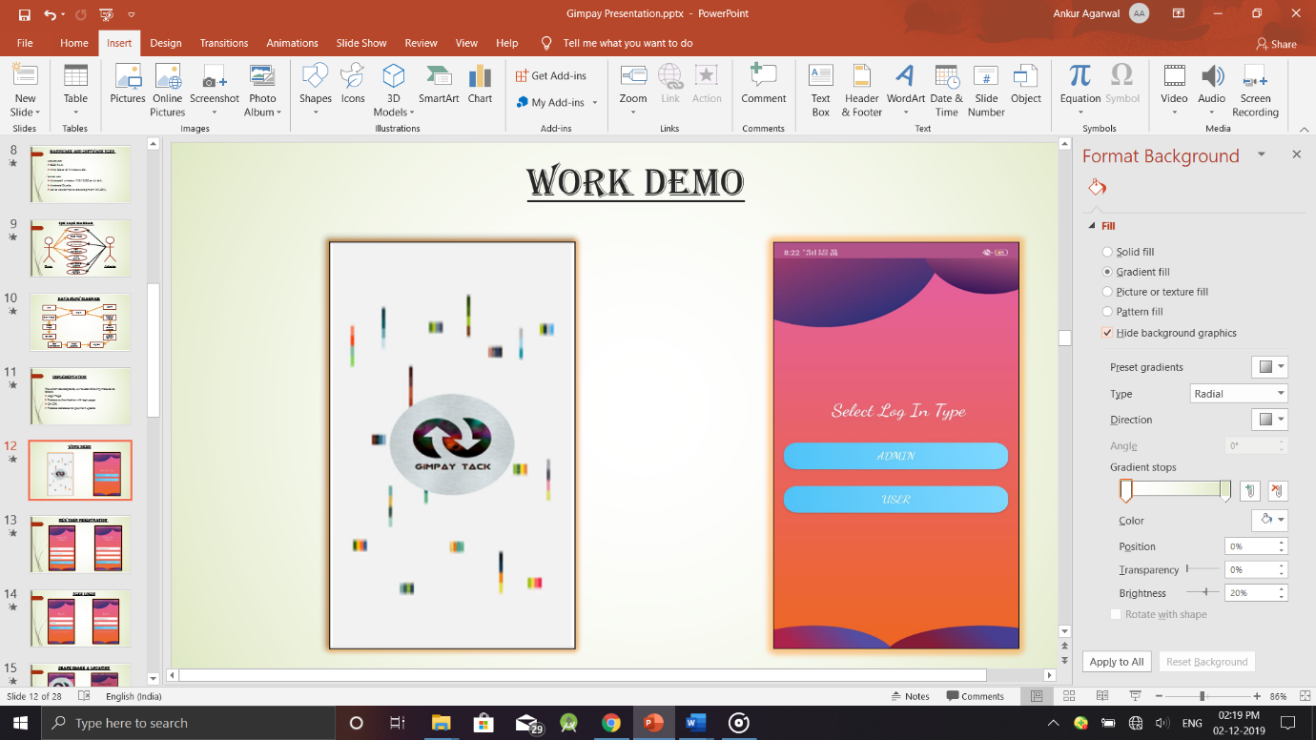

This activity will have a splash screen of 3 sec on the launch of the activity. After that there will be login type whether user or admin is logging into the system.

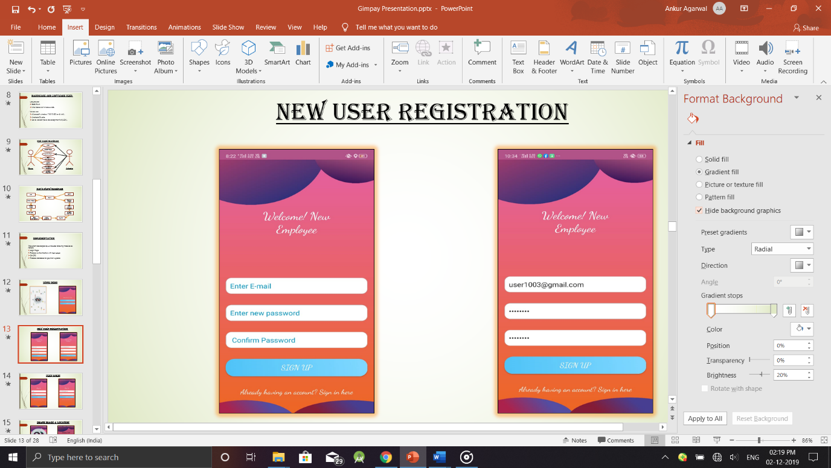

This page shows the registration of a new user by entering the mail and respective passwords to confirm his validation.

The new entry will be added to the firebase authentication record.

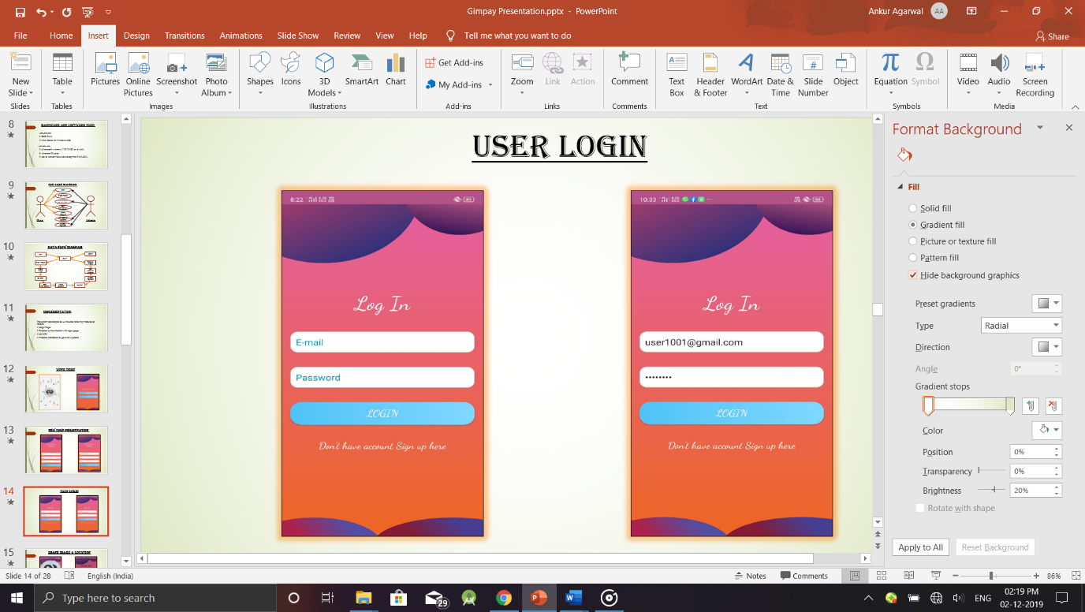

After creating the account the user can login into the application by entering the valid e-mail and password for further process

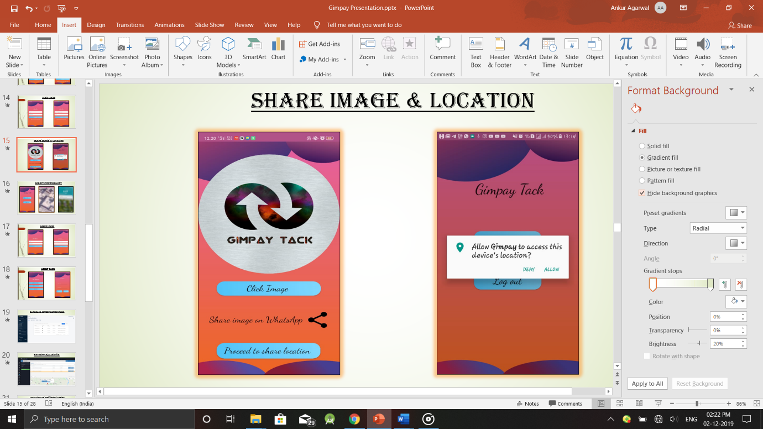

The logo here is the image view which will set the image and with the help of share button, it will be shared via whatsapp. Then, after clicking button proceed to share location the application will ask for permissions to access location mandatory for security reasons.

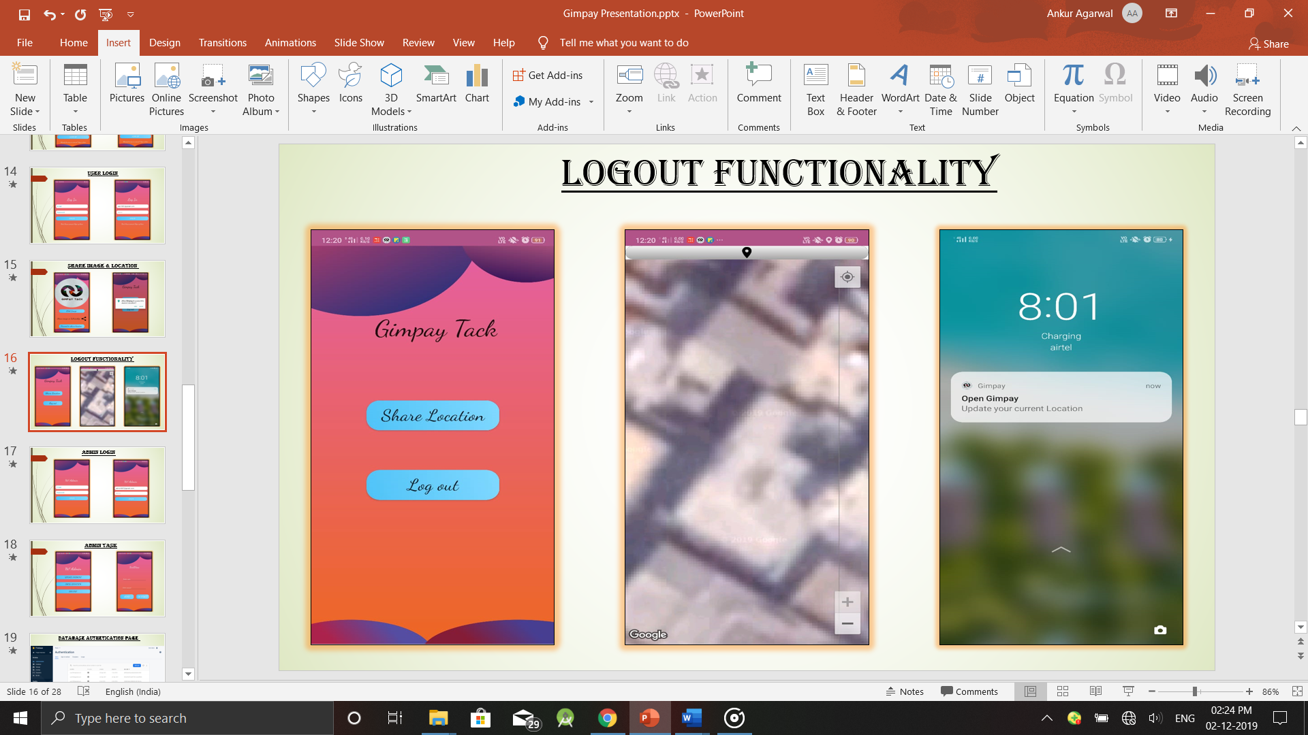

When he will allow permissions he shares his location and then logout of the system. Then he will receive the notification updates after a time span of one hour which will prompt the user to send his updated location.

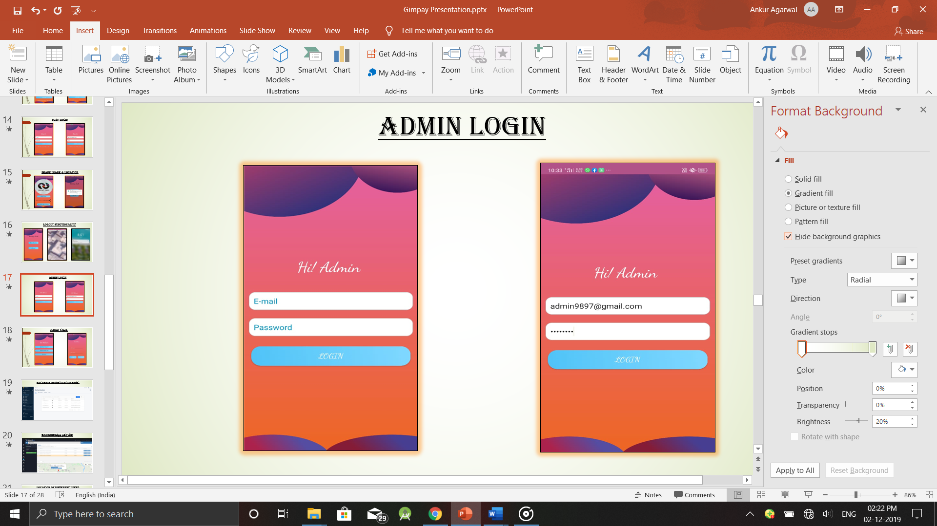

Admin part now starts. He does his login by entering the valid mail and password.

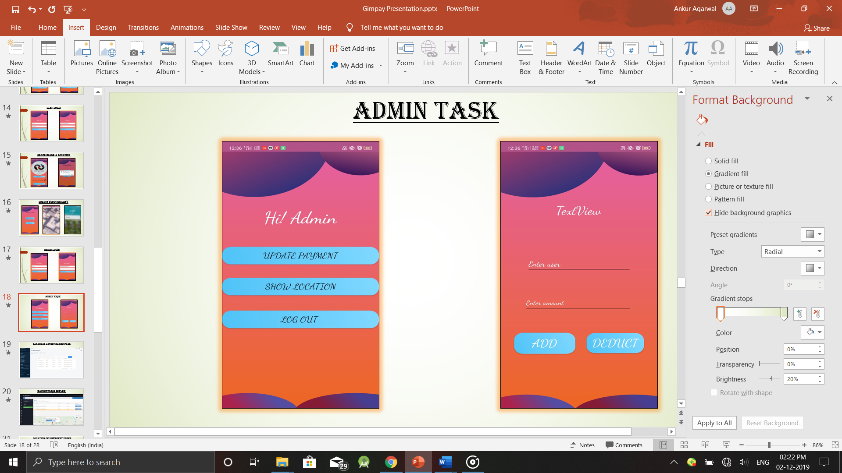

After logging in, he has three choices.

Update payment:-After checking the location of respective user whether to add or deduct the amount he enters the respective mail and the amount.

Show location:- This part opens backendless server geolocation where he can view the status.

Log out:- After all the work done he can logout of the system.

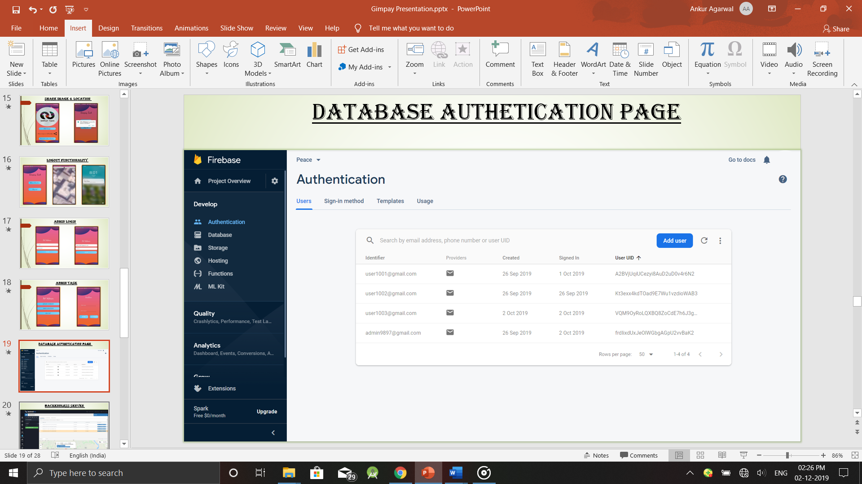

This is the firebase authentication dashboard which shows the three users and one admin registered to the application with different user–id.

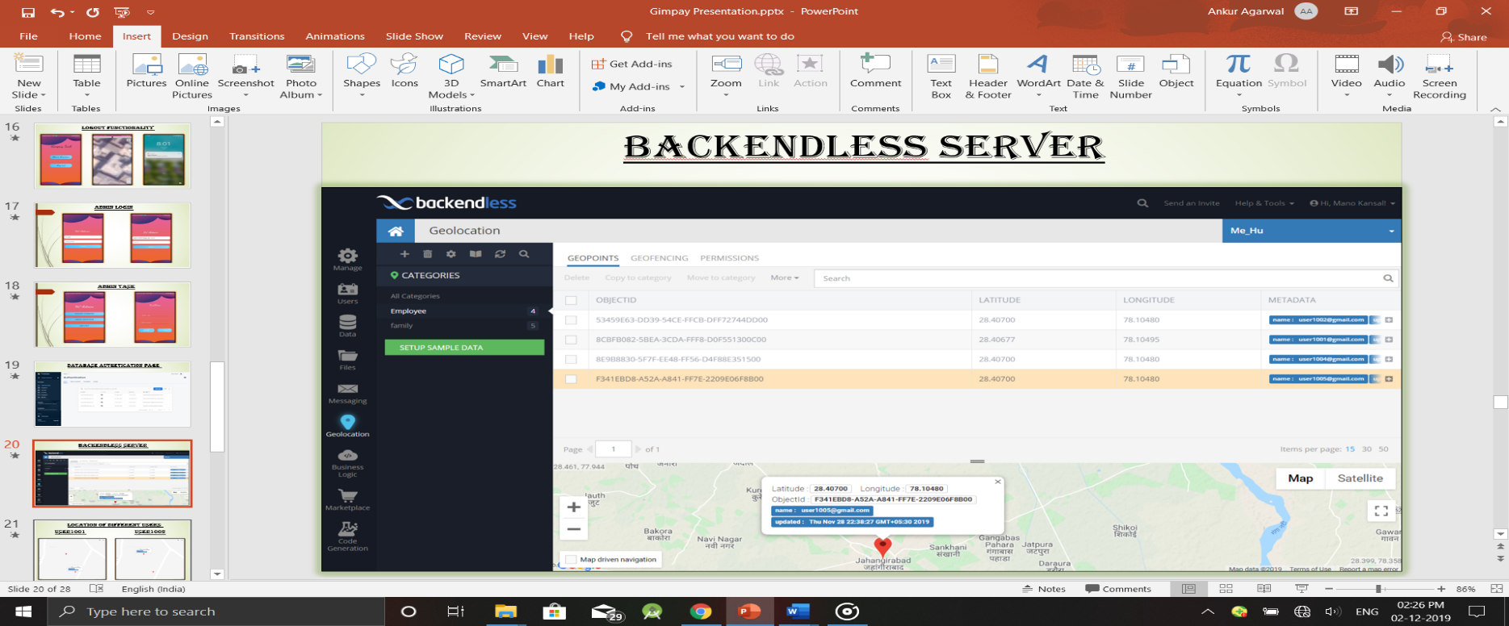

This is the backendless server showing geolocation of the employees in the category Employee.

The mark on the map has metadata which has the latitude and longitude , the registered mail, and a reference object.

It also has the data and time zone which indicates the time at which the last known location is updated.

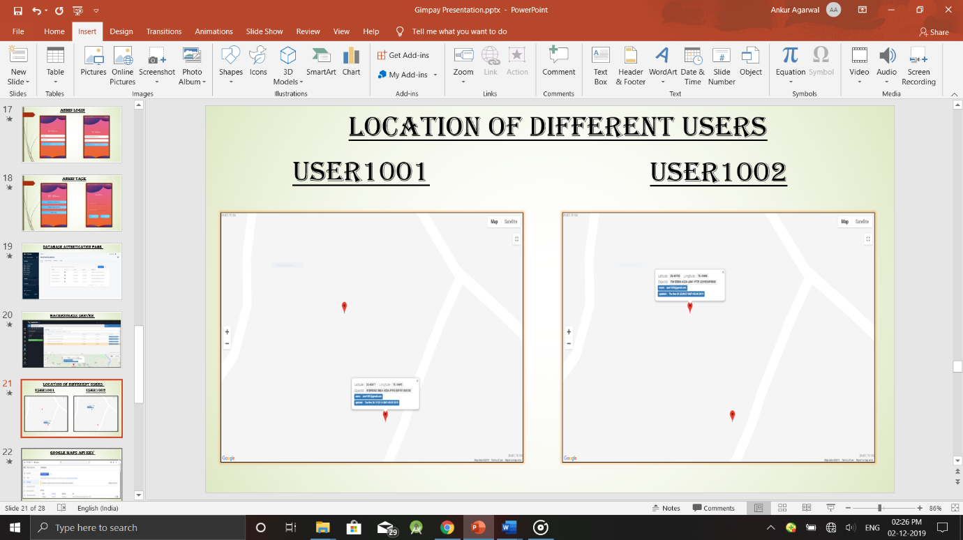

This is the zoomed in part of the google map of two respective users (user1001 and user1005).

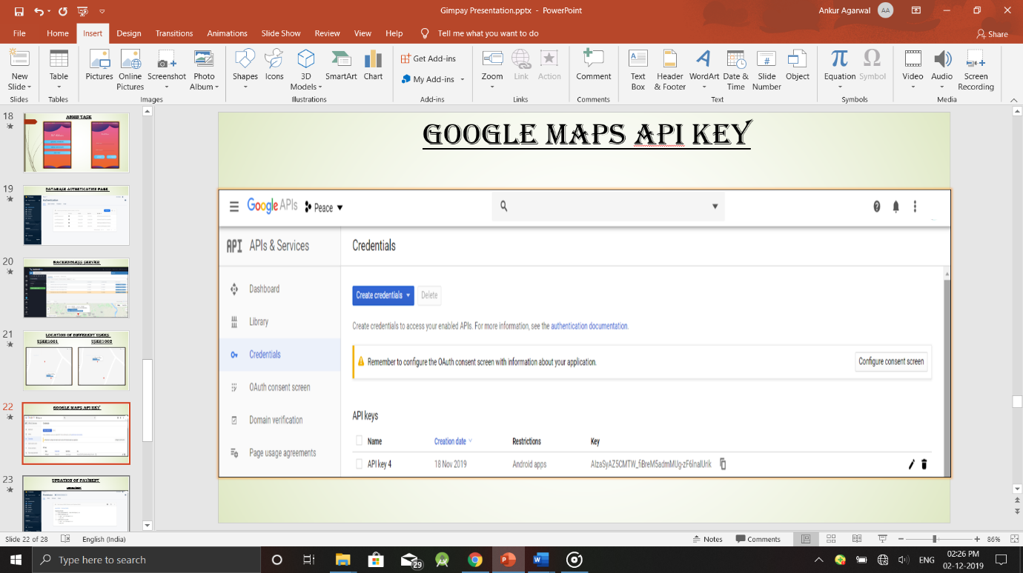

This is the google maps API key generated.

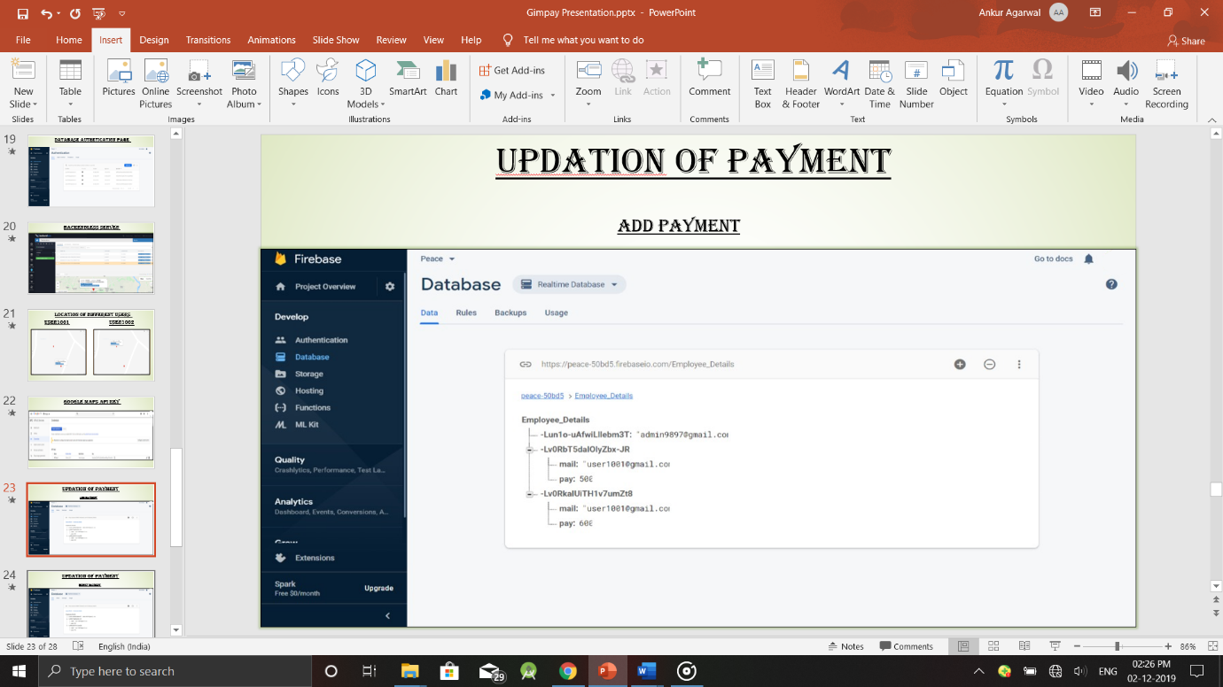

The project name is Peace which has the database Employee_details.

At first, we will send the reference key of admin to the database.

Then, reference key of a respective user will be created everytime when the admin adds or deducts the payment.

This is add part of the payment of user1001 which was previously 500 updated to 600.

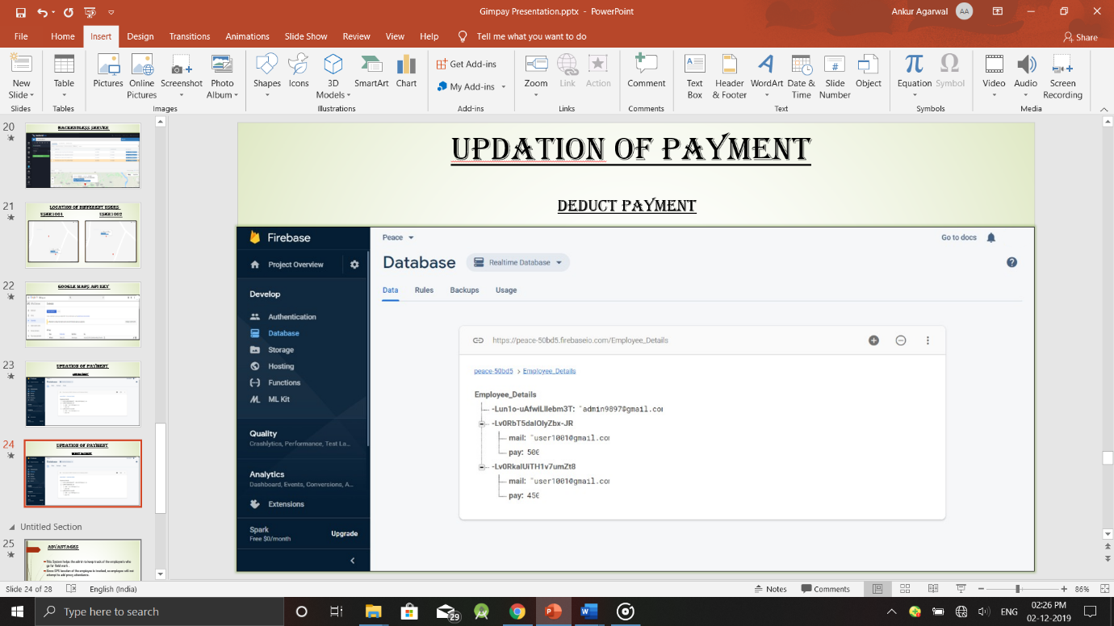

This is the deduct part of the user1001 which updated the payment to 450 which was previously 500.

**SCREENSHOTS OF CODE:**

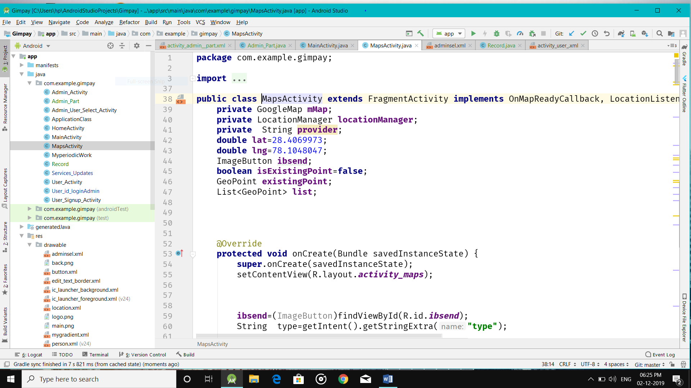

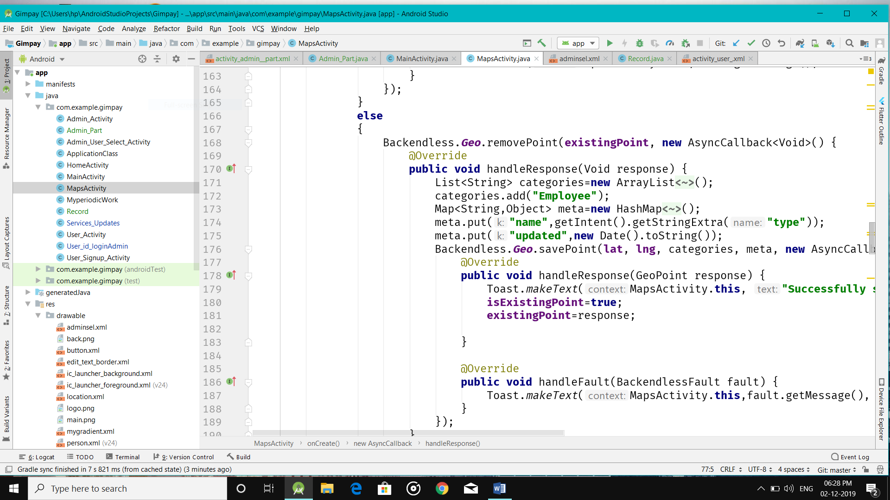

**LIMITATIONS AND FUTURE ENHANCEMENT**

**LIMITATION:**

The limitation of this project is it may fail to provide the service when the user system fails to work i.e, the internet connection is not working.

**FUTURE ENHANCEMENT:**

* The project can be extended to a web application which may only include HR and admin logins.
* The HR may ensure that admin had honestly updated the payments of employees.
* May be applicable in delivery system where the employees do part-time job and payment will be on the basis of packages delivered.

**CONCLUSION**

* It helps the admin to fairly update the payment of the employeess.
* Since the location of the user is tracked in any mishappening the past location of the user can be seen to track him.
* It also maintains the monthly record of salary on daily basis.

**REFERENCES**

* Book – Professional Android 4 Application Development *by Reto Meier*
* <https://developer.android.com>
* YouTube
* http://Stackoverflow.com
* Udemy